
Lifelong Learning
Initial Teacher Training
Guide to Online Resources

GENERAL ITEMS WHICH ARE CAN BE ACCESSED BY ALL

The Itslife website: The content of Itslife is organised around a set of key Teaching and Learning Themes and Issues, and the home page is at: http://www.itslifejimbutnotasweknowit.org.uk/
Reading material can be found across most of the site, but the library section has a range of relevant publications available for download at: http://www.itslifejimbutnotasweknowit.org.uk/librarystart.htm
The Reflective Practice Online CPD resource: This is what it sounds like .. an online resource with many items for understanding and making use of reflective practice. It’s at: http://reflectivepractice-cpd.wikispaces.com/
Twitter: Short items of news and relevant weblinks, comment etc (all in 140 characters!) You can follow Jim Crawley (teachology) on twitter at: https://twitter.com/#!/teachology
An archive of tweets (with some spam!) is at http://goo.gl/qvd5X
Delicious is a weblink saving and sharing resource, and there is a collection of relevant links at the address: http://www.delicious.com/jimcrawley

BATH SPA UNIVERSITY ITEMS WHICH CAN BE ACCESSED BY ALL

A blog by the Education librarian, Barbara Molloy, which describes itself as follows:

‘This blog is designed to keep staff and students up to date with BSU library matters of interest to the School of Education. You can post comments back to me, or email me separately if you prefer. Barbara Molloy’

The blog home page is at http://molb1.wordpress.com/ Do take a look, as there is a good deal which is useful for off campus students.

RESOURCES WHICH MUST BE ACCESSED WITH A BATH SPA UNIVERSITY USERNAME AND PASSWORD

E books
You can search for e-books in the BSU Library catalogue at:

http://library.uwe.ac.uk/uhtbin/cgisirsi/FQ5bt6BoKO/NEWTONPARK/71640633/60/93/X ‘

If you search for ‘assessment’ one of the books which is listed is the useful Phil Race book ‘the lecturers’ toolkit’. The result looks like this

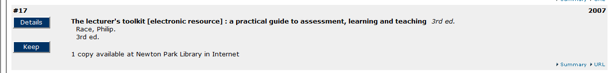

To go to the book, click on the ‘url’ link, and you will then need to log in with the BSU username and password to view the book. You may well be shown other relevant titles which you can view as ebooks.

Online Journals .. E-Journals

The E Journals website provides online access to over 140 journal titles, selected by our academic staff for their particular value to BSU research. You can also search the table of contents of many other journals. The link on the library website which takes you to the log in is at:
http://www.bathspa.ac.uk/services/library/electronic-services/e-journals.asp

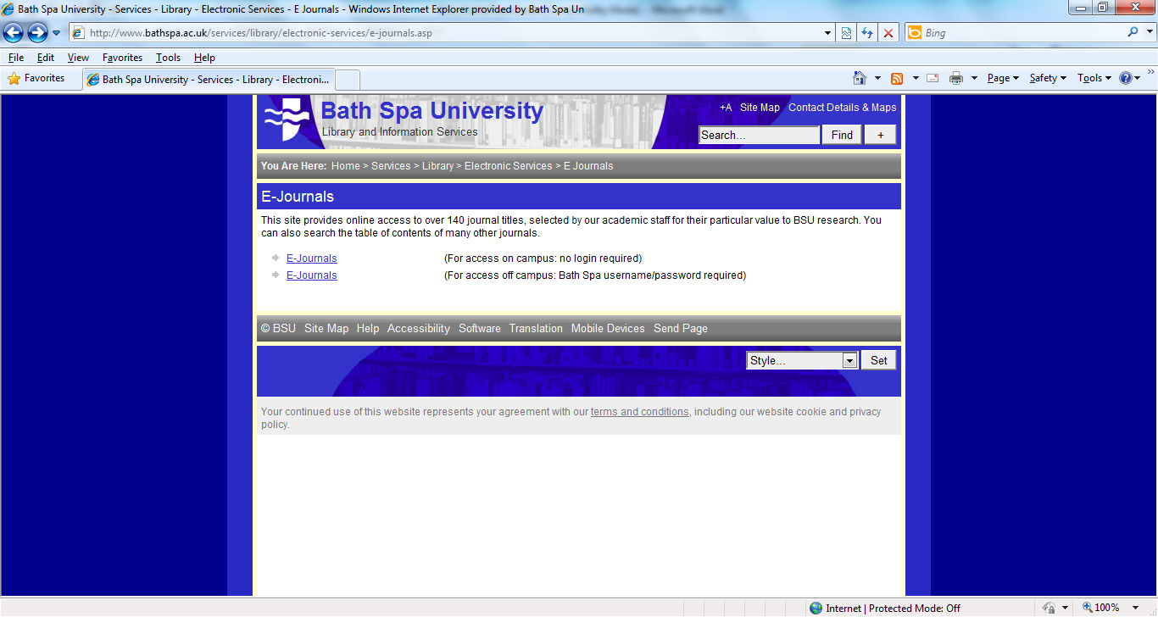

The page above is where you will arrive, and you will probably need to click on the lower link for ‘off campus’ access.

When you arrive at the EBSCO host home page as shown below, two tips for searching:

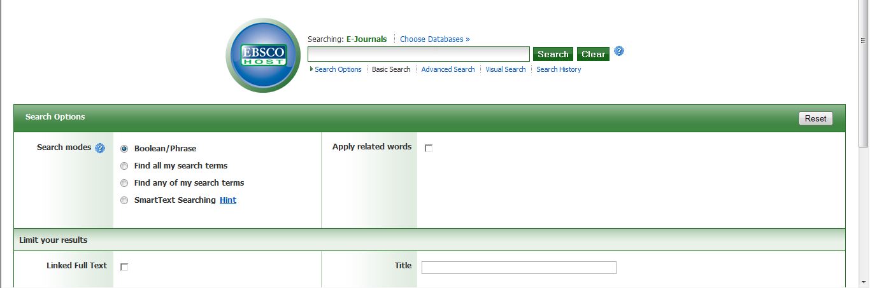
- Before searching, click on ‘choose database’ and choose ‘education research complete’.
- When searching click the ‘full text’ option.
STARTING WITH MINERVA
(With thanks to the Bath Spa University ‘Mark’s Help’ web site)

What 'Minerva' is
Minerva is a teaching tool – Bath Spa University's VLE or Virtual Learning Environment. Minerva is accessed online via a web browser such as Internet Explorer.

How do I log in?
Go to the Bath Spa University Minerva log in screen:
https://minerva.bathspa.ac.uk

Log in by entering your Bath Spa University username and password in the correct spaces, and clicking on the ‘login’ button.

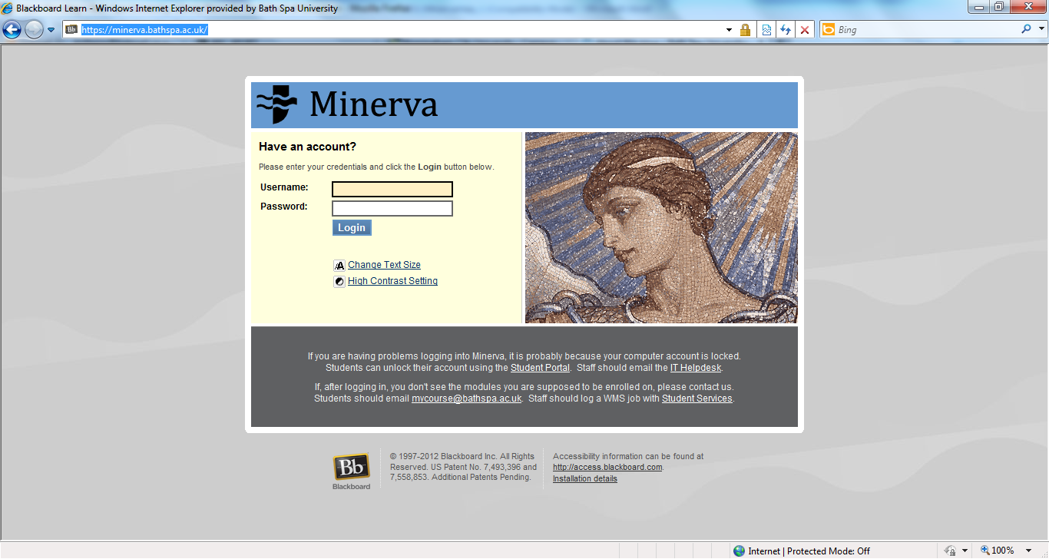

If you do not remember your username or password, contact the university help desk on 01225 8756500 from 08:30 to 5:00.

Once logged in you will see a screen which may list a number of modules you are enrolled in.

You only need to access the area titled EX-LLITT1112-2011-1012: CERT ED / PG CERT (LIFELONG LEARNING) Leader: JIM CRAWLEY, which contains the relevant content for all trainees on the Cert Ed / PG Cert.

Click on the title and you will the see the screen below:

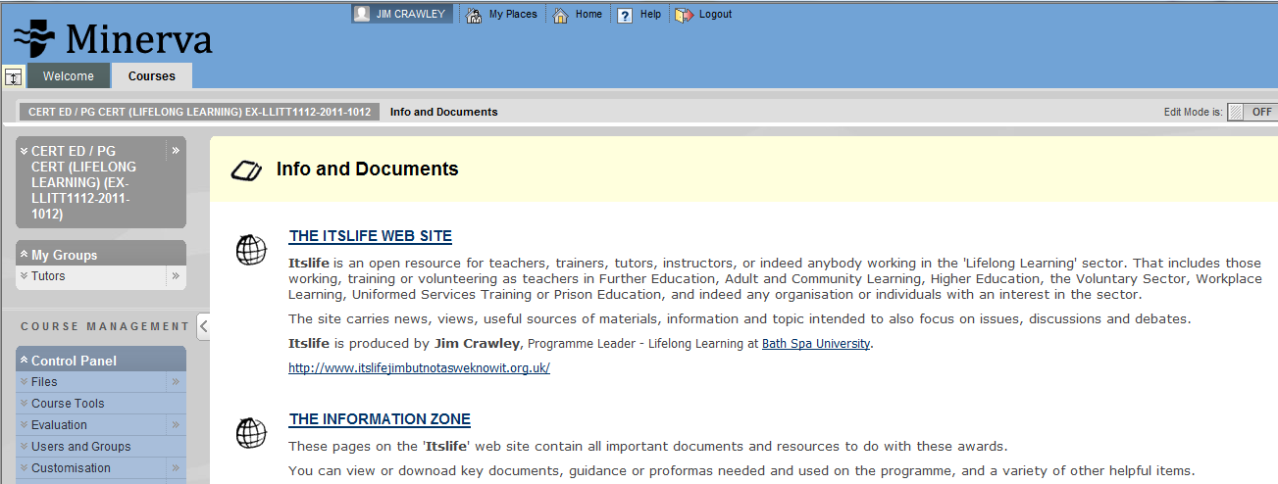
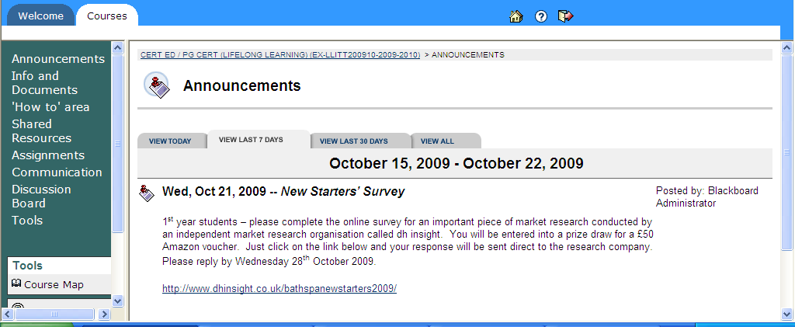
Once you are logged in to Minerva, the best way to get familiar with the content is to browse around.

SUBMITTING WORK TO ‘TURNITIN’ FOR A PLAGIARISM CHECK

Click on ‘assignments’ and you will see the screen below

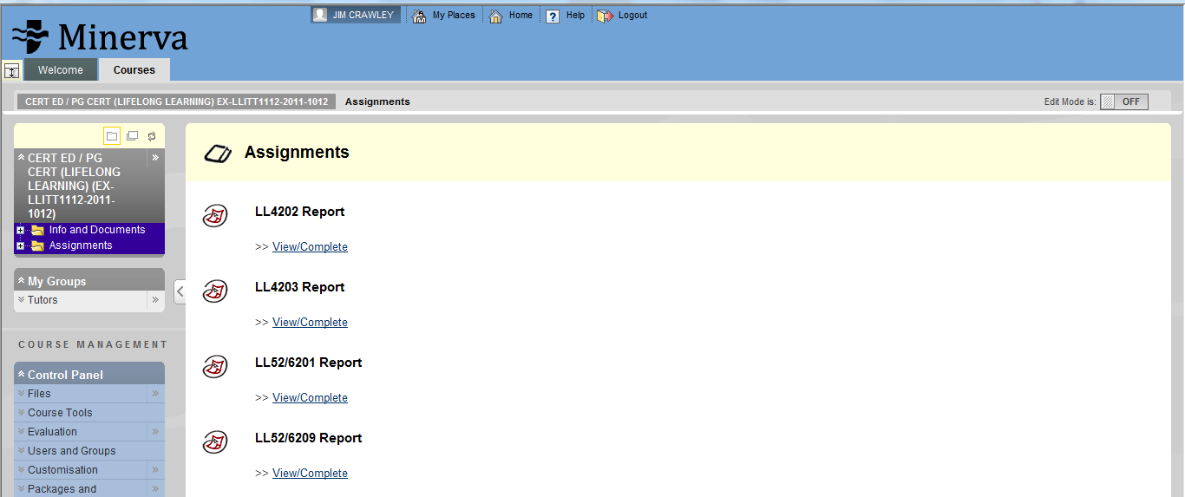

Click on the link below the assignment which needs to be submitted
You will see the screen below. Select "single file upload" from the "choose a paper submission method" pull down menu
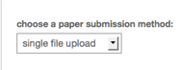
Enter the paper title for the submission in the appropriate field
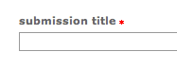
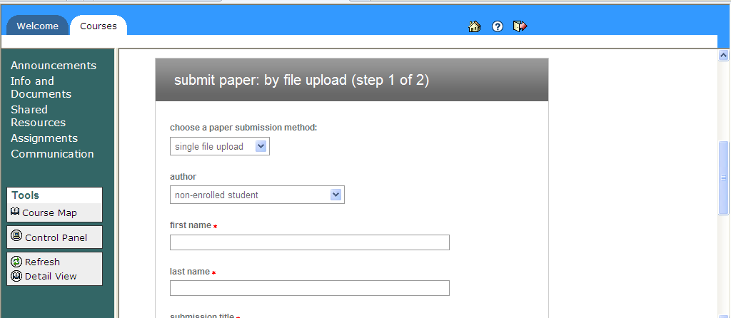
Click browse to find the file on your computer
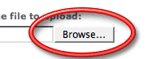
Find the file on your computer and click open



Click upload

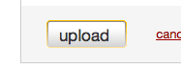
Review the file and click on the "Submit" button to finalise the submission
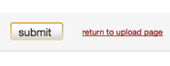
Viewing Originality Reports

Go into the course area

Click on the Assignments link

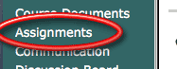
Click on the View/Complete link to open up the assignment inbox for that assignment
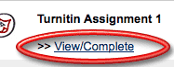
Click on the Originality Report icon to the right of the paper's title



